U27-4 OPTIONS

STANDARD EQUIPMENT

Safety system
- Travel lock system
- Fully locked hydraulic system
- Swivel motor with disc brake
- Travel alarm

Working equipment
- 2 working lights on canopy and 1 light on the boom
- Auxiliary hydraulic circuit 1 and 2 with proportional control and oil flow adjust dial

Operator’s space
- Weight-adjustable suspension seat (PVC seat)
- Retractable seat belt
- Hydraulic pilot control levers with wrist rests
- Digital panel with diagnosis function
- ROPS/OPG (Top Guard Level I) canopy
- Switch and harness for beacon light
- 12V power outlet
- Two pattern selection system
- Cup holder
- Horn

Engine/Fuel system
- KUBOTA original engine
- Double-element air cleaner
- Fuel level indication buzzer
- Electric fuel feeding pump

Undercarriage
- 2-speed travel
- Double flange track roller
- Short pitched rubber crawler
- Auto down shift

Hydraulic system
- Variable displacement pump
- Auxiliary hydraulic circuit piping to the arm's end
- AUX 1 &2 proportional flow control of auxiliary circuit
- AUX oil flow adjust dial
- Third line hydraulic direct return for AUX 1
- Straight travel circuit
- Hydraulic pressure checking ports

Others
- Tool storage space

OPTIONAL EQUIPMENT
  - Safety valve for boom and arm
  - Battery isolator support kit
  - Foot pedal

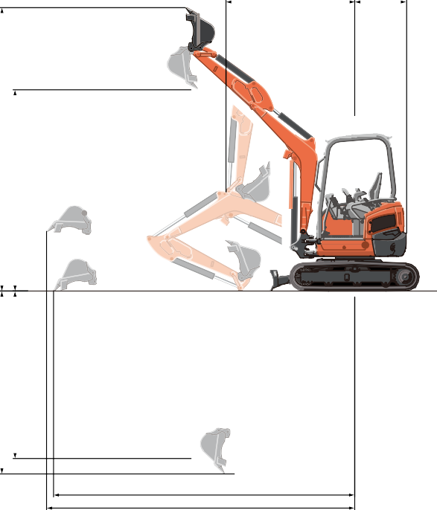 G H
E F

WORkINg RANgE
C A
D B

Model |  |  |  | U27-4
A | Max. digging height |  | mm | 4370
B | Max. dumping height |  | mm | 3100
C | Max. digging depth |  | mm | 2820
D | Max. vertical digging depth |  | mm | 2580
E | Max. digging radius at ground |  | mm | 4630
F | Max. digging radius |  | mm | 4740
G | Min. turning radius | W/O swing | mm | 1970
 |  | W swing | mm | 1539
H | Min. tail turning radius |  | mm | 790

LIFTINg CAPACITY
LIFT POINT HEIGHT  (m) |  | LIFTING CAPACITY OVER-FRONT BLADE DOWN  unit = kg |  |  | LIFTING CAPACITY OVER-SIDE  unit = kg
 |  | LIFT POINT RADIUS (m) |  |  | LIFT POINT RADIUS (m)
 |  | 2.5 | 3.5 | MAX | 2.5 | 3.5 | MAX
GL | 2.5 | – | 400 | – | – | 300 | –
 | 1.5 | 560 | 440 | 420 | 480 | 290 | 230
 | 0.5 | 800 | 510 | 440 | 440 | 280 | 230
 | 0 | 850 | 530 | – | 440 | 270 | –

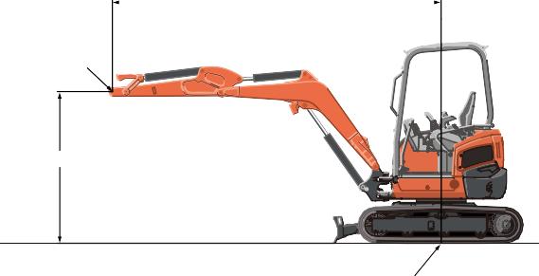 Lift Point Radius
Lift Point
Lift Point Height
Axis of Rotation

Machine with canopy and rubber crawler, without bucket

SPECIFICATIONS

Model |  |  | U27
Type of ROPS / FOPS |  |  | Canopy
Type of tracks |  |  | Rubber
Engine | Model |  | Kubota D1105-BH
 | Output (SAE J1995 gross) | HP (kW)/rpm | 20.8 (15.5) / 2400
 | Output (SAE J1349 net) | HP (kW)/rpm | 20.0 (14.9) / 2400
 | Displacement | cc | 1123
Dimensions | Overall length | mm | 4100
 | Overall height | mm | 2420
 | Overall width | mm | 1500
 | Min. ground clearance | mm | 307
Hydraulic system | Pump capacity | /min. | 28.8 variable × 2 / 19.2 gear × 1
 | Auxiliary hydraulic flow AUX1 / AUX2 | /min. | 48.0 / 19.2
 | Max. breakout force Bucket / Arm | kgf | 2645 / 1260
Drive system | Travel speed Low / High | km/h | 2.6 / 4.3
 | Max. traction force | kgf | 3069
 | Tumbler distance | mm | 1560
 | Crawler length | mm | 1990
 | Shoe width | mm | 300
 | Ground contact pressure | kPa (kgf/cm2) | 22.9 (0.23)
Swing system | Unit swing speed | rpm | 9.9
 | Boom swing angle Left / Right | degree | 75 / 55
Blade | Dimensions Width / Height | mm | 1500 / 300
 | Max. lift above ground | mm | 360
 | Max. drop below ground | mm | 320
Hydraulic oil (reservoir/system) |  |  | 22 / 37
Fuel reservoir |  |  | 33
Operating weight (Including operator’s weight @ 75 kgs) |  | kgs | 2570
The company reserves the right to change the above specifications without notice. This brochure is for descriptive purposes only. Please contact your local Kubota dealer for warranty infomation. For your safety, Kubota strongly recommends the use of a Rollover Protective structure (ROPS) and seat belt in almost all applications.

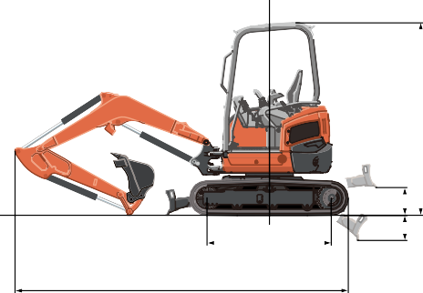DIMENSIONS
1560
4100
2420

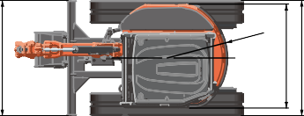
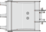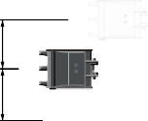Unit: mm
615 600
1500
1350
1500
320 360

